
Primary Author: Dr. Karen Hershberger
Collaborators: Dr. McLean Gunderson
Dr. Tracy Baker
Dr. Jessica Rippe
Dr. Masatoshi Suzuki

Model for Intramuscular Injection into Epaxial Muscles

CONTEXT – With this model, you will be introduced to a proper technique to give medications by intramuscular (IM) injection into the epaxial muscles of dogs and cats.

LEARNING OUTCOMES – By the end of this activity, you should be able to:
1. Identify the anatomic landmarks used to identify epaxial muscles in the lumbar region: iliac crest & spinous processes of the caudal lumbar vertebrae.

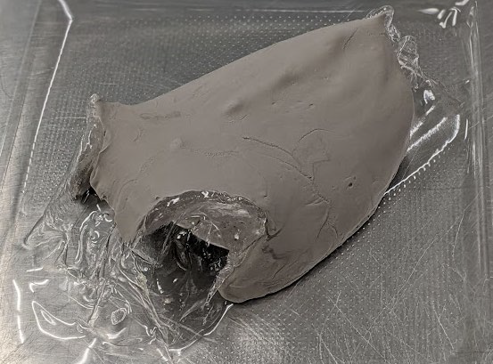

2. Place your non-dominant hand on these landmarks to isolate these epaxial muscles on the right side of the animal.

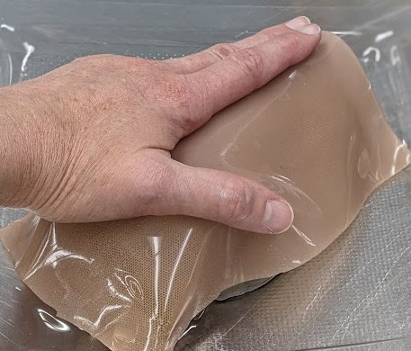

3. Use your dominant hand to hold the syringe and insert the needle straight into the epaxial muscles (perpendicular to your non-dominant hand).

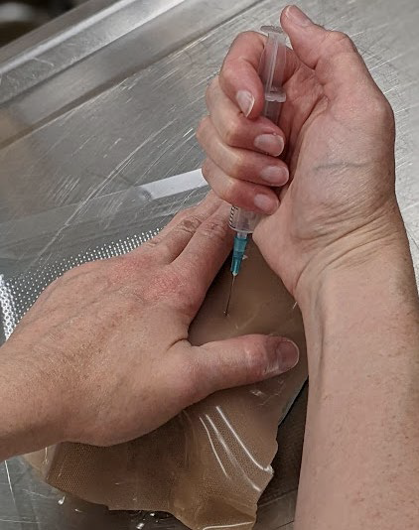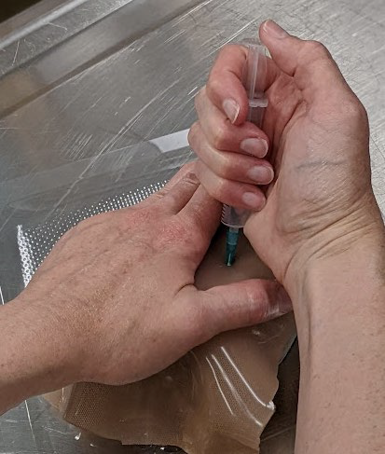
4. Manipulate the syringe with your thumb to administer medication into the right epaxial muscles.

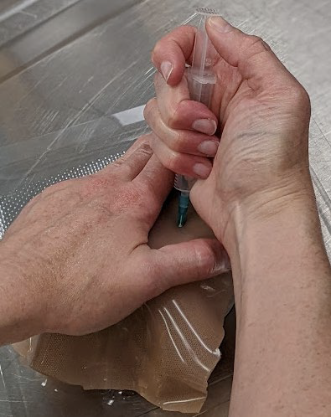
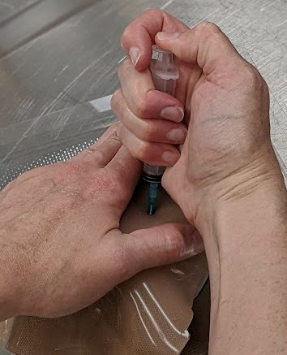

Draw back on plunger to make sure needle not in a blood vessel. Depress plunger to administer medication

5. Repeat this activity, using your non-dominant hand to administer the medication into the epaxial muscles on the left side of the animal.
Terms of Use:
Creative Commons License (BY-NC-SA)
This license enables re-users to distribute, remix, adapt, and build upon the material in any medium or format for noncommercial purposes only, and only so long as attribution is given to the original creator(s). If you remix, adapt, or build upon the material, you must license the modified material under identical terms.

CC BY-NC-SA includes the following elements:
BY: credit must be given to the original creator(s).
NC: Only noncommercial uses of the work are permitted.
SA: Adaptations must be shared under the same terms.

